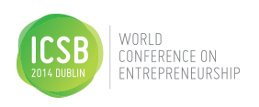

**Women’s Entrepreneurship Forum**

**Register**

[**HERE**](https://events.conferencepartners.ie/ei/getdemo.ei?id=184&s=_48W0QNJ3H)

**11 June 2014 14:00 – 18:00**

**Location: Double Tree by Hilton,**

**Burlington Road, Dublin**

**Meeting Room 6**

Women entrepreneurs worldwide are transforming their entrepreneurial potential into economic and social impact of all kinds. Join us for the launch of **TESS**: The new global gathering place that ignites conversations, connections and community in the women’s enterprise ecosystem. **TESS** engenders a broader conversation, creates collisions of smart, committed people, and provides a collegial atmosphere to learn new things.

**The Program**

**Talks**

**Host: Orlaith Carmody**, Managing Director, MediaTraining.ie

Learn from global leaders in the Women’s Entrepreneurship ecosystem as they share insights on research, education, policy and practice in short compelling presentations. Engage in interactive discussion with the experts during post-talk Q&A.

**Jean O’Sullivan**: Manager Female Entrepreneurship, *Enterprise Ireland*

**Paula Fitzsimons,** National Director, *Going for Growth*

**Chaewon Lee,** Associate Professor**,** *Seoul National University of Science and Technology*

**Nicola Byrne,** CEO, *11890 Directory Enquiries and Cloud90*

**Entrepreneur Expert Roundtables**

**Host: Maura McAdam, Ph.D.** Queens University, Belfast and author: *Female Entrepreneurship*

Women entrepreneurs and all participants are invited to engage with experts on the topics that matter most to them managing and leading a thriving enterprise.

**Microfinance Ireland: What you need to know:** Lorna Coleman, Microfinance Ireland

**Top Tips for Maximizing Your Team:** Caroline McEnery, The HR SUITE

**Developing Your Board:** Deirdre Smith, Green Point Consultancy:

**Accelerator Options: Why not *you*?:** Sarah O'Farrell and Amy Neale, [NDRC](http://www.ndrc.ie/)

**Social Media for Your Growing Enterprise**: Oonagh McCutcheon, Elucidate

**Opportunities in Women’s E’ship Research:** Donna Kelley, Babson College

**Community Reception and Recognition Awards**

**Host: Susan Duffy, Ph.D.** Babson College Center for Women’s Entrepreneurial Leadership

**Speaker: Bonnie Harvey,** Co-founder Barefoot Wines and Co-author of *The Barefoot Spirit.*

The afternoon concludes with a wine and cheese reception where local and global leaders from the women’s entrepreneurship ecosystem will celebrate collective achievements and continue plans for high impact collaborations.

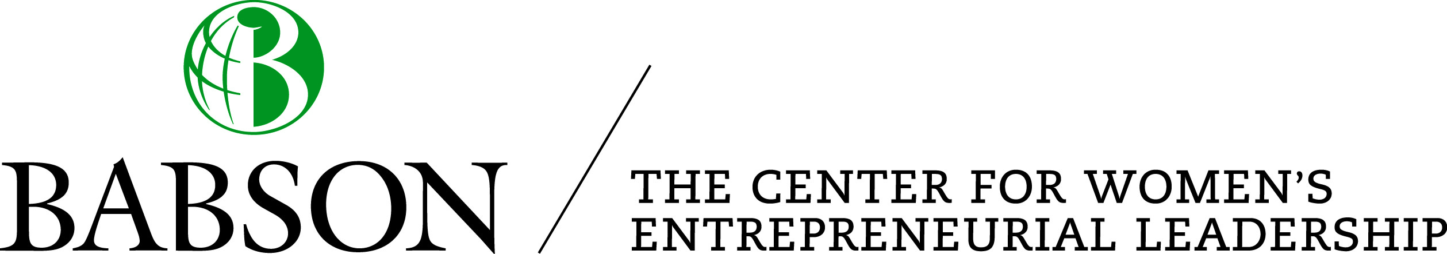

*TESS*: Diminutive of Theresa. The meaning is derived from Greek θεριζω (therizo) "to harvest."